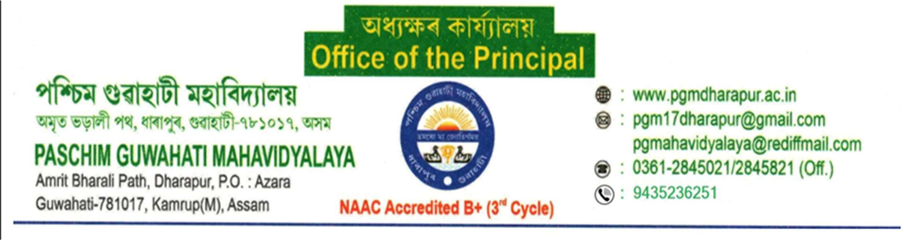
0

NOTICE

Date: 20/06/2026

This is for the information of all students of the 2023 (admitted) batch of Paschim Guwahati Mahavidyalaya that students who are still facing any issues related to their examination of 5th semester results (GU) are requested to report the same immediately.
The issues may include "Result Not declared", missing marks, absentee, incorrect entries, discrepancies in results, or any other result-related problems.
All concerned students are asked to contact Mr. Sourav Jyoti Goswami and provide the necessary documents for further action.
The last date for reporting such issues will be on 25th June, 2026. Students are requested to submit their concerns within the given time period, as requests received after the deadline may not be considered.
Students are advised to treat this matter as important and ensure timely compliance.

By Order Principal

